Lab 1

# Part 1

## Flow Diagram

## 

## Output

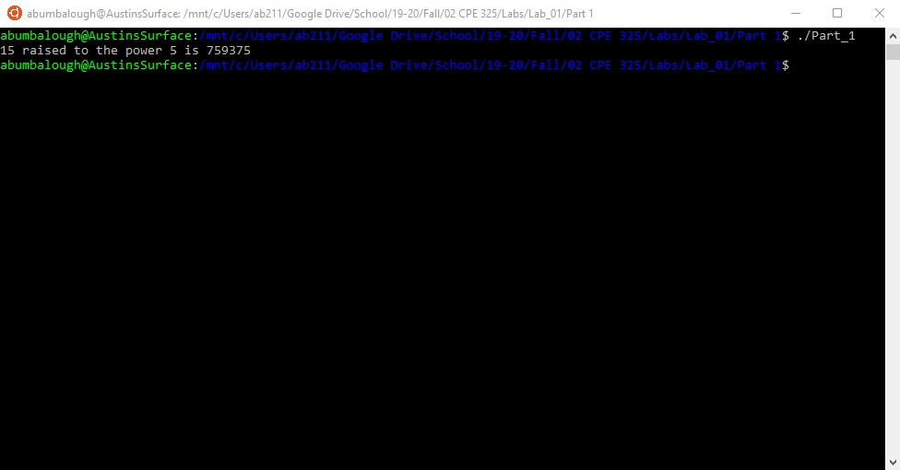

## Source Code

#include <msp430.h>

#include <stdio.h>

/*

--------------------------------------------------------

*

File

: Lab_01_Part_01/main.c

*

Description

: Create user-defined power function.

*

Input: Constant values defined in program

* Output: Stdout

*

Author: Austin Bumbalough

* Lab Section: 08

*

Date: 8/27/19

*

--------------------------------------------------------

*/

long int myPower**(**int**,** int**)** **;**

int main**(**void**)**

**{**

WDTCTL **=** WDTPW **|** WDTHOLD**;** // stop watchdog timer

// Declare parameter values

int a **=** 2**;**

int p **=** 11**;**

long int c**;**

c **=** myPower**(**a**,**p**);**

printf**(**"%d raised to the power %d is %ld\n"**,** a**,** p **,**c**);**

**return** 0**;**

**}**

long int myPower**(**int a**,** int b**)** **{**

long int c **=** 1**;**

// c = 1 for case where b = 0

// for all other cases, c = a^b

**for** **(**int i**=**0**;** i**<**b**;** i**++)** **{**

c **\*=** a**;**

**}**

**return** c**;**

**}**

# Part 2

## Flow Diagram

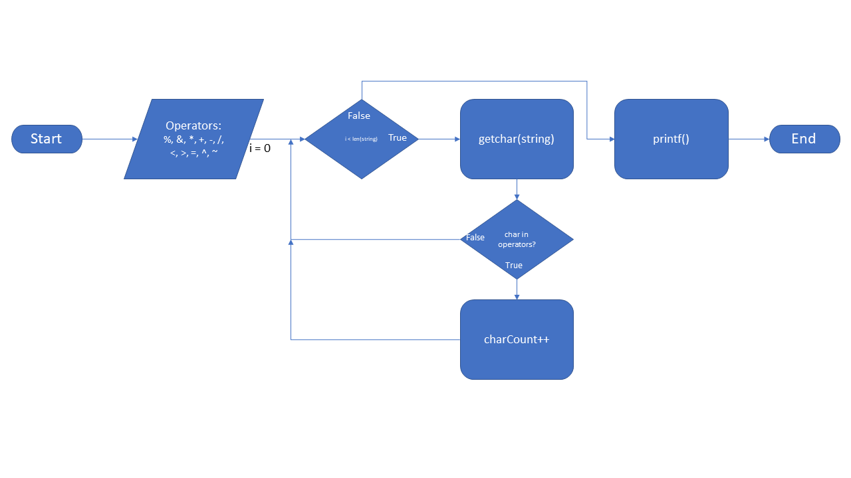

## Output

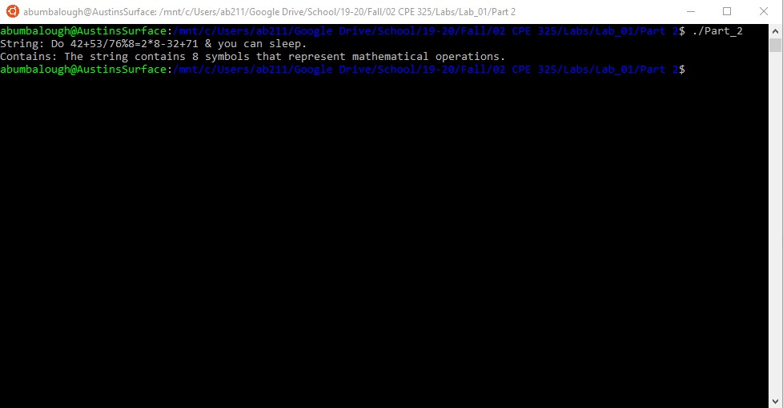

## Source Code

#include <msp430.h>

#include <stdio.h>

/*

--------------------------------------------------------

*

File

: Lab_01_Part_02/main.c

*

Description

: Search for math operators in a string.

*

Input: Constant values defined in program

* Output: Stdout

*

Author: Austin Bumbalough

* Lab Section: 08

*

Date: 8/27/19

*

--------------------------------------------------------

*/

int main**(**void**)**

**{**

WDTCTL **=** WDTPW **|** WDTHOLD**;** // stop watchdog timer

// Define array of tokens to compare string against

char operators**[**11**]** **=** **{**'%'**,** '&'**,** '*'**,** '+'**,** '-'**,** '/'**,** '<'**,** '>'**,** '='**,** '^'**,** '~'**};**

char testString**[]** **=** "Do 42+53$$76%8=2*8-32+71 & you can sleep."**;**

// Declare variable to hold size of arrays for iteration boundary

size_t opSize **=** **sizeof(**operators**);**

size_t stringSize **=** **sizeof(**testString**);**

// Initial counter variable

int mathCharCount **=** 0**;**

char currentChar**;**

**for** **(**int i**=**0**;**i**<**stringSize**;**i**++)** **{**

// Get character from string

currentChar **=** testString**[**i**];**

**for** **(**int j**=**0**;**j**<**opSize**;**j**++)** **{**

// Compare current character to token

**if** **(**currentChar **==** operators**[**j**])** **{**

// Increment counter if match is found

mathCharCount**++;**

**}**

// Repeat for all tokens

**}**

// Repeat for all characters in string

**}**

printf**(**"String: %s\n"**,** testString**);**

printf**(**"Contains: The string contains %d symbols that represent mathematical operations.\n"**,** mathCharCount**);**

**return** 0**;**

**}**